Vermont Climate Action Plan - Working Together for a Thriving Vermont

WHAT'S AT STAKE AND WHAT CAN BE DONE

As Vermonters, we know the importance of coming together to face big challenges. We also know that our health, our economy, and our environment are all connected. That’s why the State of Vermont is developing a Climate Action Plan to make sure that all of our communities can overcome the challenges of a changing climate and thrive into the future.

The Vermont Climate Action Plan aims to dramatically reduce harmful climate pollution and to prepare Vermont for a warming climate that threatens our communities, livelihoods and landscapes. Addressing climate change presents opportunities for new industries and jobs in clean energy and other low carbon solutions and in preparing our communities for extreme weather. While climate change affects everyone, some people face greater risks due to race, ethnicity, income, health, age and occupation. Advancing solutions that address the needs of Vermonters facing the greatest risk is key for a resilient and equitable Vermont.

Learn more about the goals of the Global Warming Solutions Act and the work of the Vermont Climate Council.

How much of a risk does climate change pose for Vermont?

The last decade was the warmest on record and the impacts are already being felt from more high heat days and increasingly severe storms. Temperatures may rise 2-3.6°F in Vermont by 2050. If action isn’t taken soon, by 2080 summer in Vermont will feel similar to northwest Georgia, with more than 17 days a year exceeding 95℉. Average rainfall will also increase during the winter and summer months.
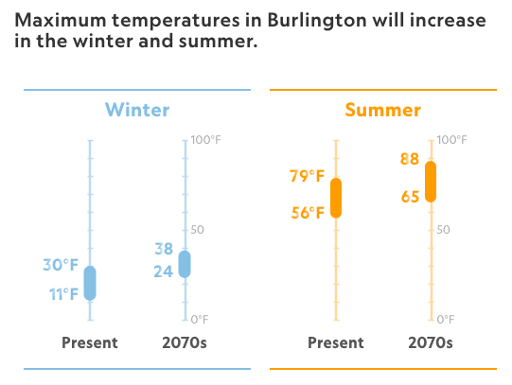
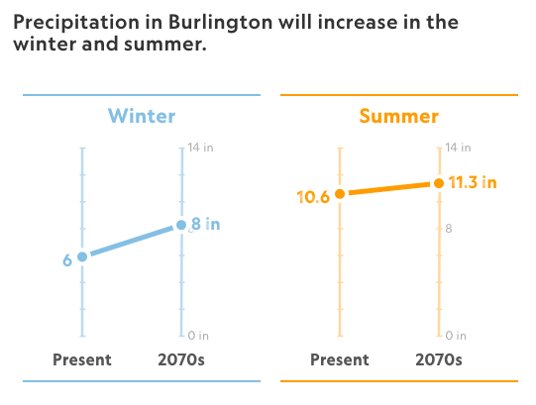
Source: National Geographic

Climate change poses numerous risks for Vermont. Here’s what we’re facing:

- More rain and flooding: Precipitation will increase and become more frequent and intense, particularly in mountainous areas with an 80% increase in the likelihood of high stream flows, threatening homes, infrastructure, communication and transportation systems.

- Changes to Farming and Sugaring: An extended growing season may create new crop opportunities, yet also more weeds and pests. Rising temperatures can also lead to heat-stress for livestock.

- Different forests: Ecosystems will be increasingly threatened by invasive species and spruce-fir forests may be replaced by oak-hickory forest as seasons shift.

- Health concerns: Respiratory conditions, heat-related illnesses, extreme weather-related injuries and tick and mosquito-borne diseases are likely to become more common.

- Not everyone is impacted equally: Those without air conditioning, outdoor workers, the elderly, people with disabilities, low-income communities, BIPOC communities and those that lack housing are more at risk. If no action is taken, climate change will worsen poverty and chronic health problems.

If action isn’t taken soon, these risks will get worse in the coming decades. The good news is that solutions are available. If we act now to cut climate pollution, we can limit the climate impacts we will face in the future.

What can be done to help Vermont thrive?

The Vermont Climate Action Plan is considering a number of pathways to address climate change and strives to integrate an equity perspective with a goal of ensuring that communities most impacted by climate change and an energy transition will be considered.

Draft pathways include:

Resilient Agriculture and Ecosystems
- Sustain and Expand Carbon Capture and Storage in Vermont’s Natural and Working Lands, Soils and Waters
- Sustain, Restore and Enhance the Health of Vermont’s Natural Working Lands, Soils and Water
- Support Vermont’s Farmers, Foresters and Land Workers to Cut Climate Pollution and Increase Resilience to Impacts
- Grow and Connect Local, Sustainable Natural and Working Land Economies, Markets and Food Systems

Efficient Transportation Systems and Vehicles
- Electrify Transportation
- Opportunities to Advance Low Carbon Fuels
- Increase Transportation Choices
- Land Use and Smart Growth

Access to Clean, Reliable Energy
- Achieve 100% Renewable Electricity Supply Statewide
- Manage Energy Use to Limit Cost Impacts and Climate Pollution
- Access to Electrification for All

Better Buildings
- Building Enhancement Through Weatherization at Scale
- Better Heating Through a Clean Energy Standard

Climate Action in Waste, Industry and Agriculture
- Cut Climate Pollution from Wastewater Treatment Facilities
- Reduce Emissions from Industry
- Leverage, Expand and Adapt Agricultural Programs that Deliver Climate Benefits
- Invest in Working Lands Conservation and Education
- Foster Partnerships to Generate Strategies for Farmers to Address Climate Change

Strong Rural Communities
- Increase Local and Regional Resilience Capacity
- Enhance Resilience in Transportation, Communications, Water/wastewater and Energy Infrastructure
- Support the Reduction of Fossil Fuels in Municipalities, School Districts and Residences.
- Promote Resilient Land Use
- Access to Safe, Energy Efficient and Affordable Housing, Jobs and Services for All Vermonters

