Social Cost of Carbon and Cost of Carbon Model Review
  - Analyses and Recommendations to Support Vermont’s Climate Council and Climate Action Plan

Prepared by:
David G. Hill, Ph.D.
Elizabeth Bourguet
Chris Neme
Gabrielle Stebbins

July 2021
Contents
About the Authors 3
Acknowledgements 3
Acronyms & Abbreviations 4
Introduction 5
Executive Summary 6
Department of Public Service’s Cost of Carbon Model 6
Social Cost of Carbon and Discount Rates 9
Cost of Carbon Reduction Model 10
Background 10
Value and Limitations of the Tool 11
Potential Enhancements to the Tool 13
Adding Measures 13
Depth and Pace of Emissions Reductions 15
Revision of Inputs, Assumptions and Formulae 16
Summary 17
Social Cost of Carbon and Discount Rates 17
Background 17
Damage and Abatement Cost Methods for Estimating SCC 18
Deliberative Polling 20
Results and Recommendations 21
SCC and Discount Rate Recommendations 24
Appendices 25
A. Cost of Carbon Model 25
Access, Inputs, Assumptions and Formulae 25
B. Social Cost of Carbon Survey and Results 30

About the Authors
Energy Futures Group (EFG) is a clean energy consulting firm based in Hinesburg, Vermont and with offices in Boston and New York. EFG specializes in the design, implementation and evaluation of programs and policies to promote investments in energy efficiency, renewable energy, other distributed resources, and strategic electrification. EFG staff have worked on these issues on behalf of energy regulators, other government agencies, utilities and advocacy organizations across the United States, Canada, Europe, and China.
David Hill is a Managing Consultant who joined EFG in early 2020, after 22 years of employment with VEIC. He is known nationally for his advancement of sustainable energy program design and implementation support, scenario modeling for clean energy futures, and renewable energy policy.
Liz Bourguet is a Senior Analyst at EFG who joined EFG in 2020 after graduating from the Yale School of Forestry and Environmental Studies with a Master of Environmental Management degree and who focuses on energy policy analysis and climate change mitigation strategies.
Gabrielle Stebbins is a Senior Consultant at EFG and specializes in the development of policy and programs for promotion of renewable energy, strategic electrification, and energy efficiency, with a special focus on efforts to integrate all three.
Chris Neme is a Principal and Co-Founder of EFG. During his more than 25 years in the industry, Chris has helped clients in 30+ states, 7 Canadian provinces and several European countries with a variety of energy efficiency, demand response, strategic electrification and other distributed energy resource market assessments, programs, and policies.

Acknowledgements
The Cadmus/EFG team would like to thank members of the Vermont Climate Council, its subcommittees and task leaders, members of the public, and the private and public sector employees of numerous organizations for their contributions and concern on the topic of climate change. We appreciate the Data & Science Subcommittee members and other participants in the July 21, 2021 remote meeting for participating in the polling exercise related to the Social Cost of Carbon and Discount Rates. We also appreciate the project management and coordination provided by the Global Warming Solutions Act Project Director at the Agency of Natural Resources (ANR), and the technical consultant team leadership provided by our colleagues at Cadmus Group LLC. Any omissions or errors in this report are the responsibility of the EFG team authors.
AESC | Avoided Energy Supply Components
AEV | All-electric vehicle
ANR | Vermont Agency of Natural Resources
CAP | Climate action plan
CCR | Cost of carbon reductions spreadsheet model
COP | Coefficient of performance
CO2 | Carbon dioxide
CO2e | Carbon dioxide equivalent
DSSC | Data and Science Subcommittee
EAN | Energy Action Network
EFG | Energy Futures Group
EVT | Efficient Vermont
GHG | Greenhouse gas
GWSA | Vermont Global Warming Solutions Act
IAM | Integrated assessment model
IWG | Interagency Working Group
ICE | Internal combustion engine
LEAP | Low Emissions Analysis Platform
MSRP | Manufacturer suggested retail price
NYDEC | New York State Department of Environmental Conservation
OEO | Vermont Office of Economic Opportunity
PSD | Vermont Department of Public Service
PHEV | Plug-in hybrid electric vehicle
RFF | Resources for the Future
RNG | Renewable natural gas
SCC | Social cost of carbon
VCC | Vermont Climate Council

Acronyms & Abbreviations

Introduction
In 2020, the Vermont Legislature passed Act 153, commonly referred to as the Vermont Global Warming Solutions Act (GWSA). The GWSA establishes targets to reduce greenhouse gas emissions by not less than 26 percent from 2005 levels by 2025, by not less than 40 percent from 1990 levels by 2030, and by not less than 80 percent from 1990 levels by 2050. The GWSA also established the Vermont Climate Council (VCC) and directs the VCC to develop a Climate Action Plan (CAP) identifying strategies and programs to meet the GWSA targets, with a due date of December 1, 2021, for the first plan and updates due every four years.
Energy Futures Group (EFG) is engaged as part of a team led by Cadmus Group LLC (Cadmus), serving as technical consultants to support the development of Vermont’s CAP by the VCC. The overarching objective is to support the VCC in development of the CAP by EFG as part of the Cadmus team providing technical support to the VCC and its sub-committees. This report is one of our team’s deliverables under Task 3.
Our scope of work for this report incorporates two primary tasks. First, to conduct and report upon our review of the Vermont Department of Public Service’s (PSD) “Cost of Carbon Reductions” (CCR) spreadsheet model. Second, to develop and present material on the method and discount rate assumptions for estimating the social cost of carbon (SCC) in the Vermont CAP.
Regarding review of the CCR model, the team reviewed the tool to assess its analysis value and limitations and to review the assumptions, inputs and formulae of the costs and benefits associated with different technologies, including identifying gaps or modifications to measures included in the model. To complete this work, the team reviewed the workbook and met with PSD staff on multiple occasions to ask clarifying questions and to further inform our understanding of the tool.
To provide technical support and recommendations for the SCC and discount rates our team has conducted a literature review and a polling exercise conducted during one of the Data and Science Subcommittee (DSSC) meetings.

Executive Summary

Department of Public Service’s Cost of Carbon Model
The Vermont Department of Public Service’s Excel-based “Cost of Carbon Reduction” (CCR) model was initially developed in 2019 to help the Department make informed recommendations to the state legislature regarding the relative merits of different policies and strategies for meeting the state’s emission reduction goals. The tool compares the costs of specific activities and what those activities save in avoided carbon, to other activities. For example, “What is the financial cost of Vermont’s solar net-metering policy and how much does it save in carbon emissions, compared to the financial cost of a heat pump water heater rebate and how much that saves in carbon emissions?”
The Cadmus/EFG team reviewed the model to identify the strengths and limitations of the tool as well as recommend potential enhancements and modifications.
Regarding the value and limitations of the tool, every model has tradeoffs. The CCR tool has value for understanding the relative cost-effectiveness of near-term investment (i.e., over the next several years) in different emission reduction measures. As an Excel-based tool, it is generally easy to use, update and refine as new information becomes available.
However, the simplicity of the tool also means that its value becomes more limited the further one looks into the future. There are at least two reasons for this. First, the tool’s conclusions regarding costs per ton of emission reduction are based on current estimates of the costs as well as the current emission reduction benefits of the specific technology. These are likely to change, and potentially quite significantly.
Second, there will be interactions over time between many of the emission reduction measures in the tool that are not currently captured by the tool. Specifically, the tool currently compares costs of emission reductions per measure under the presumption that the level of reduction realized in the first year a measure is installed will remain unchanged over the measure life. For example, a fossil-fuel heated home that is weatherized is expected to achieve a specific amount of savings over 25 years. However, if heat pumps are installed ten years after the weatherization, then the fuel savings resulting from the weatherization for the next 15 years are likely to be diminished (although the weatherization likely may reduce the heat pump impact on the grid, thereby then increasing the weatherization value to some degree). While the tool could be modified to account for potential interactions, to do so comprehensively across all measures in this tool may not be as efficient as using pre-existing tools purposely designed to provide this type of dynamic analysis (for example, the Low Emissions Analysis Platform (LEAP) model currently being used for other VCC related work).
Another area that the tool does not address is the balance between the cost of a particular measure, and its depth and pace of savings. For example, a relatively inexpensive measure might appear to be a better choice initially when compared to another measure that costs more upfront, but if the lower cost measure is only able to provide a small level of total savings it may not be preferable in the long run. The goal for the CAP is, ultimately, to achieve the required emission savings; therefore, the least expensive measure that provides fewer savings for, perhaps, a shorter time may likely not result in achieving Vermont’s various goals and requirements as quickly as another measure that may cost more initially.
Additionally, there are measures that may not provide carbon savings directly but that act as “enablers” to the overall shift to a decarbonized energy future. In some cases, those additional benefits may be even more critically important to enabling deployment of other measures that, overall, may provide larger emission reductions. Examples include battery storage and, as the grid becomes increasingly renewably powered, electric efficiency measures as well as technologies such as controls; in the latter cases, these measures may not necessarily result in reduced GHG emissions, but rather they provide the ability for the grid to handle increased (and increasingly variable) demand overall.
In the current tool, these measures would have a cost but would appear to provide no benefit, which is likely not accurate. Nevertheless, the tool provides value in that the team will be able to utilize the workbooks to provide input into the LEAP model, which can then be used to inform the CAP. Overall, the tool can be either integrated into the LEAP model or used as a complementary, but separate, tool.
Upon review of the tool, the Cadmus/EFG team identified enhancement suggestions such as adding a variety of heat pump technologies; identifying potential options for commercial building opportunities and industrial electrification opportunities; and incorporating biofuels as well as district heating. The Team also identified more specific revisions regarding inputs, assumptions, and formulae.
Overall, the CCR modeling tool is a useful, helpful starting point in providing short-term upfront costs of various Vermont clean energy offerings. However, as efforts and actions to decarbonize the power, transportation, building, agricultural and industrial process sectors scale up in Vermont and beyond, the variations and interactions in the costs and benefits – as well as the benefits from measures that may not provide significant carbon reductions - will likely be more efficiently captured by other available tools.
Looking forward, the team will continue to provide support to ensure the appropriate data points are incorporated into the LEAP model. This will include a broad review to identify sources for data points, analyzing the applicability of those data points within the Vermont context and developing alternative approaches to assumptions if needed. Figure 1 provides an overview of the relationship we envision between the PSD’s CCR model, the work completed by the Energy Action Network (EAN) on mitigation pathways, supporting workbooks to be developed by our team to document LEAP modeling inputs, the LEAP model, the economic analysis model (IMPLAN) to be run by the Cadmus team, and the Climate Action Plan.

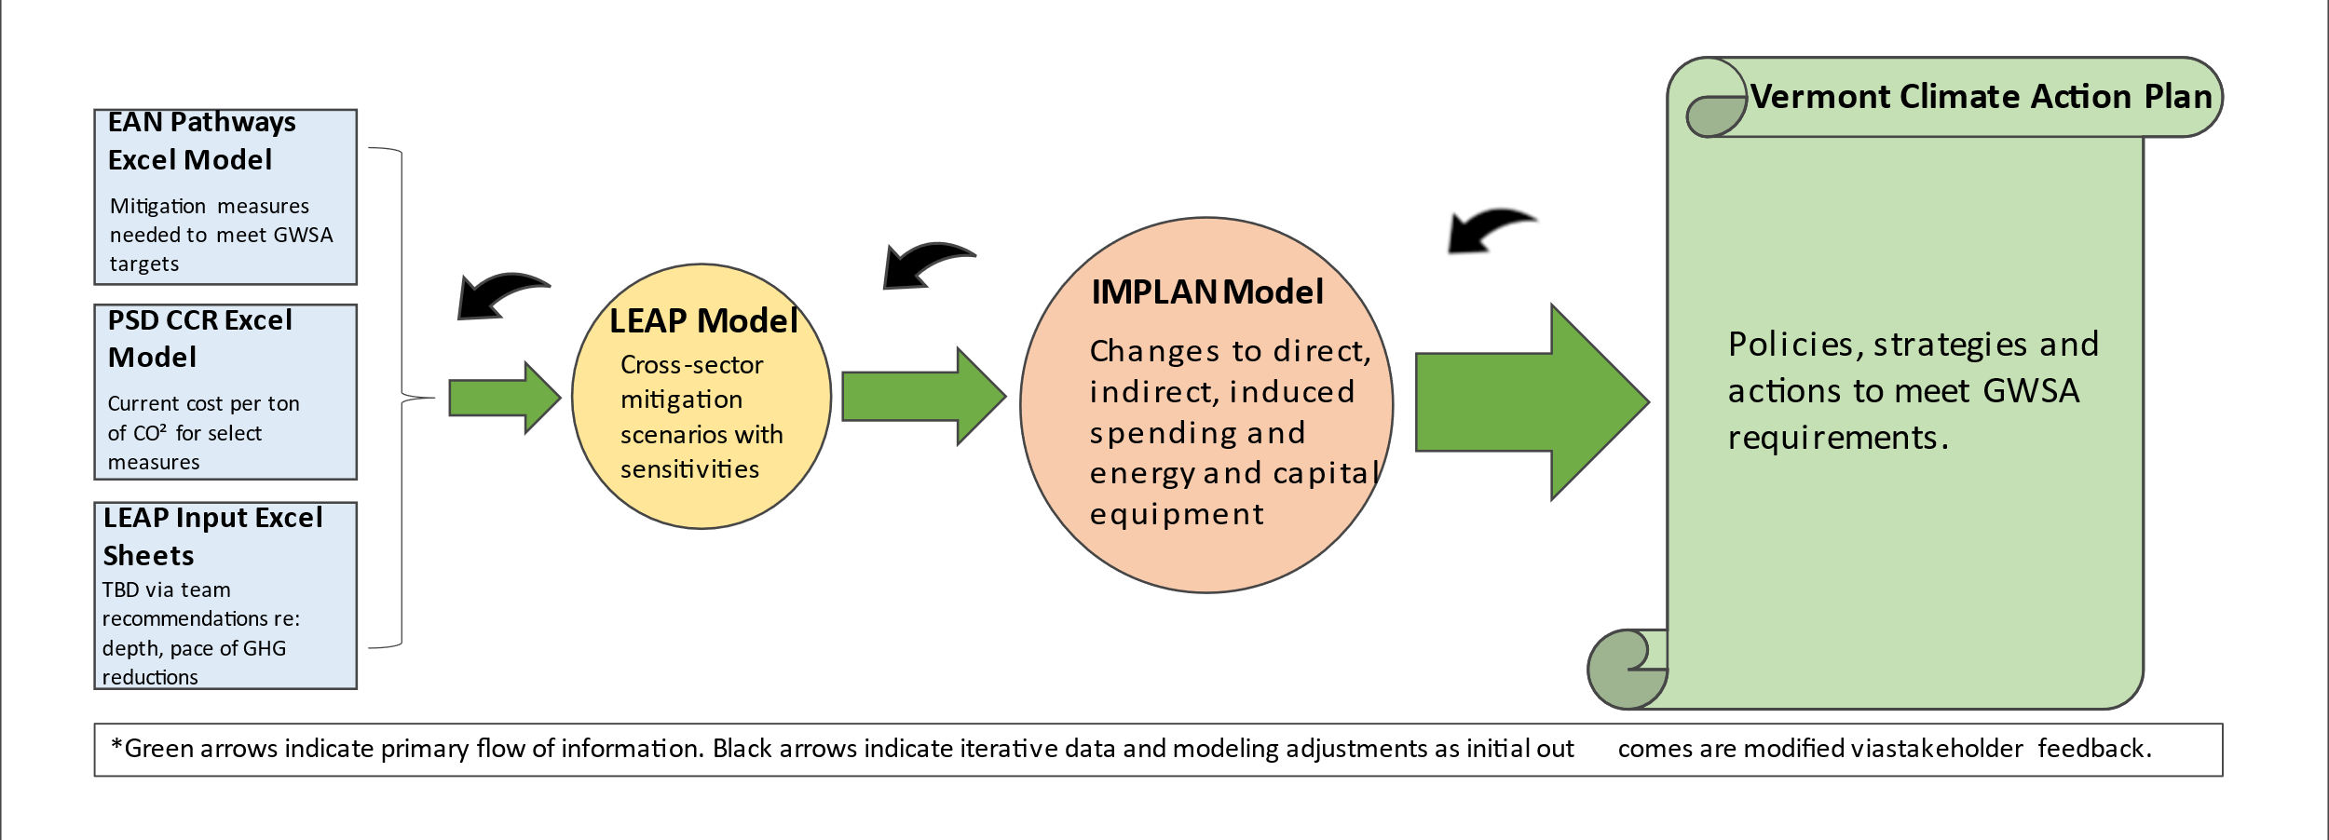
Figure 1: Flow Chart of Modeling Supporting Vermont’s CAP
The Cadmus/EFG team will leverage multiple analyses and reports from the national, regional, and state level as we move forward. These include the EAN pathways model, the Northeastern Regional Assessment of Strategic Electrification, various technical reports providing savings and cost information available through the U.S. Energy Information Administration, Massachusetts’ 2050 Decarbonization Roadmap, New York’s current Decarbonization Pathways evaluation process which utilizes three models (RESOLVE, RECAP and PATHWAYS), and others.
Recommendations for the CCR model further detailed in the body of our report include:
- Recognize the potential strengths and shortcomings of the model’s current structure and how these are best used in support of the CAP. Data and structure are best suited to comparison of measures in the short term, and from the perspective of carbon emissions reduced per dollar of public support for incentives.
- Expand the number of measures and measure categories to represent a wider set of mitigation technologies (for example a wider variety of heat pump measures, district heating, biofuels).
- Make specific revisions to data inputs and calculations.
- Develop a detailed framework (flow chart) for considering how the CCR and other data and models are related in support of CAP development.

Social Cost of Carbon and Discount Rates
The social cost of carbon (SCC) will be an important value for the analysis of mitigation scenarios, and the economic analysis of the CAP. Investments in reducing emissions will have monetary costs and benefits (say for example the material and labor costs of weatherizing a home, and the related dollar value of fuel savings). The weatherization will also result in emissions reductions. The SCC is used to provide a value to these emissions reductions so they can be reflected in benefit cost and economic analyses of mitigation strategies and the CAP.
Estimating the SCC is complicated and technical, and the time horizon for Vermont’s CAP is extremely tight. However, there are good reference materials, and recent estimates from New England and New York that we recommend the VCC use to make decisions for the CAP. In this report we briefly review the relevant literature and discuss the two main methods, damage based and abatement cost methods for estimating SCC. Both methods are sensitive to the discount rate chosen to balance the value of future versus current impacts.
Recognizing this, we report upon a polling exercise conducted with the DSSC to identify discount rate preferences. We anticipate revising this poll based on feedback and repeating it with the VCC in August to further inform CAP analyses.
The results from the polling exercise represent a very limited and selective sample, but they suggest a 2% discount rate is appropriate as a base value for Vermont to use to determine the SCC for the CAP analyses. This discount rate is consistent with recommendations from recent New York State Guidelines, the regional avoided energy supply components cost study for New England, and anticipated values in forthcoming Federal guidelines from the Interagency Working Group (IWG) to be issued in 2022. These references are discussed in the appropriate sections of the text below.
The Cadmus/EFG team also recommends Vermont use global damage-based estimates through the year 2300 for the SCC calculations. This recommendation is also consistent with the results of the polling exercise and is aligned with recent New York State Guidelines. We provide reference to the New York Guidelines below, and the SCC values based on these guidelines are presented in Appendix B.

Cost of Carbon Reduction Model

Background
In 2019, the Vermont PSD developed an Excel spreadsheet tool for comparing the cost of different carbon emission reduction measures. For example, “What is the financial cost of Vermont’s solar net-metering policy and how much does it save in carbon emissions, compared to the financial cost of a heat pump water heater rebate and how much that saves in carbon emissions?” The tool was initially designed to help the Department make informed recommendations to the state legislature regarding the relative merits of different policies and strategies for meeting the state’s emission reduction goals.
The tool was designed to compute both the levelized net lifecycle “societal” cost per ton of CO2 reduction and the levelized net lifecycle “program” cost per ton of reduction. “Net cost” means that any benefits from the measure are subtracted from the costs. For example, the cost of electrification investments can be partially mitigated by cost savings from reductions in the consumption of fossil fuels. Indeed, in some cases, the benefits are greater than the costs, leading to a negative net levelized cost. “Lifecycle” means that costs and benefits are computed over the full life of each measure, expressed in net present value terms. Meanwhile, “measure life” refers to the number of years a piece of equipment should function and the change in savings for that measure of time. The Cadmus/EFG team’s Task 1 deliverable, the “Greenhouse Gas Inventory Review” discusses the lifecycle concept in depth, describing how the lifecycle perspective incorporates upstream impacts of a measure as well as its production and use. Given the current design and simplicity of the PSD’s CCR tool, it is the Cadmus/EFG team’s recommendation that the PSD CCR tool use measure life savings rather than lifecycle savings.
The Department has defined the “societal” perspective as including all costs and benefits incurred or realized within the state’s borders. This perspective is designed to provide insight into the relative impacts on the Vermont economy as a whole from different emission reduction measures.
The “program” perspective looks solely at the incentive costs that a state program or initiative would incur to move customers to choose to install the specified emission reduction measures. For example, if a state program were to induce school investments in electric buses by offering a $50,000 incentive to defray a $235,000 incremental cost per electric bus (relative to a standard diesel bus), only the $50,000 incentive costs would be included in the program cost calculations; the remaining $185,000 incurred by school districts would be included only in the societal analysis. This perspective provides insight into the “bang for the buck” for state’s financial resources and/or utility resources that the state could require be spent.
The Cadmus/EFG team has reviewed the Department’s tool to provide feedback on the structure and assumptions within the tool as well as how it could be used – including limitations – to inform policy. In the following sections we provide the results of our review.

Value and Limitations of the Tool
It is important to start by addressing the question of how the tool should ideally be used. In a nutshell, we believe that the tool has value for understanding the relative cost-effectiveness of near-term investment – i.e., over the next several years – in different emission reduction measures. Because it is Excel-based, it is relatively easy to use and relatively easy to update and refine as new information regarding costs and benefits of different emission reduction measures becomes available. However, the simplicity of the tool also means that its value becomes more limited the further one looks into the future.
There are at least a couple of reasons for that. First, the tool’s conclusions regarding costs per ton of emission reduction are based on current estimates of the costs of different measures and some of their benefits. Both of those things are likely to change – and potentially quite significantly – as different emission reduction measures start being installed at the scale required to meet the state’s emission reduction goals. The cost of some measures that have been purchased in relatively small numbers to date are likely to decline when they begin to be sold in much larger quantities, not only in Vermont but in other parts of the country and world. For example, the incremental cost of an electric car or electric bus may be much smaller in 5 or 10 years than today. In addition, the performance of some emission reduction measures is likely to improve. For example, we continue to see almost yearly improvements in both the efficiency of heat pumps and their ability to perform in cold temperatures. That will translate to reductions in added costs to the grid from electrification of heating. On the other hand, as the number of heat pumps installed starts to grow, the grid will likely start to become winter peaking which will change (likely increase) the costs heat pumps impose on the grid. The bottom line is that the cost per ton of emission reduction from a heat pump installed 10 years from now may be non-trivially different than implied by current assumptions in the Department’s tool.
Second, there will be interactions between many of the emission reduction measures in the tool. For example, across the population of houses in the state, the average emission reductions from weatherizing a natural gas, fuel oil or propane heated home will gradually decline over the currently assumed 25-year life of weatherization savings as a growing number of those houses also switch to either electric heat, switch to wood heat, and/or get increasing fractions of gas or delivered fuels from renewable sources. On the other hand, if homes are weatherized then the amount of added cost to the electric grid from a heat pump installed in the future will also be lower. Such interactions are not currently reflected in the Department’s tool. Instead, it compares costs of emission reductions per measure under the presumption that the level of reduction realized in the first year a measure is installed will remain unchanged over the measure life. While one could theoretically attempt to modify the tool’s assumptions to account for such interactions, that would not be easy to do in a way the comprehensively captured all of the interactive effects across all measures. Such interactions are better addressed in more dynamic planning tools such as the LEAP model currently being used to investigate and compare various emission reduction pathways for the state’s Comprehensive Energy Plan as well as for the Cadmus/EFG team’s analyses for the Climate Council. Put simply, we believe it is best to recognize this limitation of the Department’s tool and to use it for simpler assessments of the near-term relative costs of carbon emission reductions as long as all data inputs are updated on a frequent and timely basis.

Potential Enhancements to the Tool
At a high level, there are a couple of ways in which the usefulness of the tool could be enhanced:
- Including a more comprehensive list of emission reduction measures; and
- Providing more information – beyond just the levelized cost per ton of emission reduction – for each measure.

Adding Measures
Currently the tool analyzes the cost-effectiveness of fourteen different measures or measure applications – four electric vehicle measures, three renewable electric generation measures, three residential electric heating or water heating measures, two wood heating measures, and two efficiency measures (one broadly applied to all electricity customers and the other a residential weatherization measure for homes heated with fossil fuels). Though these are all important measures, the list is primarily focused on transportation and residential buildings, with limited application to commercial buildings or industrial facilities. Moreover, even within the transportation and buildings sectors, there are other measures that could potentially play an important role in meeting the state’s emission reduction goals. Thus, the tool could be enhanced through the addition of any of the following measures:
- Additional heat pump options. The tool currently analyzes only single-head and multi-head ductless mini-splits. While those are the heat pumps most commonly sold in Vermont today, they may not be the ideal solution for reducing emissions in the medium to longer-term, both because they only partially displace fossil fuel heating and because their effectiveness in reducing emissions is partially reliant on customers optimizing their use in conjunction with their remaining furnace or boiler. Other options to consider would be:
  - Centrally-ducted cold climate heat pumps. These systems, which are available in the market today, can meet the entire heating need of a home (with electric resistance back-up in the air handler or, in the shorter-term, if installed in tandem with existing fossil fuel furnaces which serve as back-up for the coldest days or hours of the winter). Approximately 30% of Vermont homes are currently heated with forced air heating systems for which such heat pumps would be the ideal system. It is our understanding that Efficiency Vermont has begun to shift its focus on these products.
  - Ground source heat pumps. Ground source heat pumps are even more efficient than air source models and experience only limited degradation of their capacity and efficiency in the coldest days of the year, meaning they do not need back-up systems and would not impose much smaller costs on the grid during winter peak periods. Their primary drawback is that they are expensive. However, they may merit consideration for some applications.
  - Central air-to-water. These systems are available today and is supported through an Efficiency Vermont incentive. While adoption rates are currently low, the degree to which the technology is undergoing research and design, combined with incentives, and the need for technology that serves hydronically heated homes, it is likely that this technology will begin to see considerable uptake.
- Other options for commercial buildings. Both weatherization and larger scale heat pump applications should be considered.
- Industrial options. Under Tier 3 of Vermont’s RPS there have been a number of custom industrial electrification projects. There is likely substantially more that could be done in this area.
- Biofuels. There are a variety of biofuels that partially or fully offset greenhouse gas emissions from fossil gas, oil and propane and that are potentially capable of playing a role in helping the state to meet its emission reduction goals. These include
  - Biogas (sometimes called renewable natural gas or RNG). Vermont Gas currently has some pilot RNG projects in the field and has pledged to replace 20% of its annual throughput with RNG by 2030.
  - Biodiesel. Limited amounts of biodiesel are already being sold in Vermont – as an alternative to fuel oil. The fuel oil industry is suggesting that significant increases in sales of such fuels are possible in the future.
  - Green hydrogen. The most likely application may be for production and use at large industrial facilities for which electrification of industrial processes is not possible or realistic.
- District heating. There has been talk for decades about bringing waste heat from the McNeil wood-burning power plant in Burlington to displace heating needs at the University of Vermont, the hospital and/or other customers. There are also likely other options, both in Burlington and other cities in the state.
To be sure, some of these options are more ready for deployment than others. Since the Department’s tool is best used to assess and compare near-term options, initial emphasis on expanding the tool should be focused on measures that are more “ready” and understood such as centralized heat pumps, biogas, biodiesel and possibly district heating. The work our team is doing for the Climate Council, as well as the work the Department is currently doing on its Comprehensive Energy Plan may suggest other additions or refinements to this list – as well as the assumptions that could be used to characterize such additional measures.

Depth and Pace of Emissions Reductions
The Department’s tool currently provides information only about the relative current cost per ton of emission reduction. Though that is very valuable information, it is only part of the picture. To inform policy choices, one also needs to know how much emission reduction can be achieved over a given period of time (e.g., five years) with each measure. It makes no sense to focus primarily on a measure or two with extremely low costs if the emission reductions they can provide are very small. Thus, we suggest that the Department consider enhancing the tool by adding estimates of five-year emission reduction potential for each measure. That would enable development of a simplified “supply curve” of emission reduction options, showing both the height of each measure “bar” (i.e., its cost per ton of emission reduction) and its width (i.e., the magnitude of emission reductions it can provide at a given cost).
In addition, it is important to recognize that some measures provide significant additional benefits beyond emission reductions. In some cases, those additional benefits may be even more critically important to enabling deployment of other measures that can provide larger emission reductions. For example, though electric efficiency measures and storage provide relatively smaller levels of emission reduction potential (because the Vermont electric grid has relatively low levels of greenhouse gas emissions), they can provide substantial cost savings and create “headroom” for adding new electric loads without the addition (or minimizing the addition) of new capital investment on the grid. There would be value in documenting such additional benefits – at least qualitatively – in presenting results from the tool.
Other co-benefits include improvements in health (resulting from shifting to cleaner energy and increasing energy efficiency) and the housing stock (particularly from weatherization). For example, there are an increasing number of studies connecting energy efficiency work with improvements in individual and public health, including a recent study by the Vermont Department of Health., Various studies and surveys also point to the role energy upgrades can play in increasing the value and durability of the housing stock. Not surprisingly, given the simplicity of the CCR tool, these benefits are not currently included in the model. As the work of the VCC continues, the Cadmus/EFG team will seek to identify how best to incorporate these benefits. For while many of these benefits are hard to quantify, that does not mean there is no value at all.

Revision of Inputs, Assumptions and Formulae
Our review has identified several inputs, assumptions and formulae that appear to require revision or that at least suggest a more detailed review than we are able to provide. We present these as a list here, with significantly more detail and explanation available in the Appendix. It should be noted that revision will be an ongoing need, as technology and market conditions continuously change. This review highlighted the below suggested revisions:
- Use electric avoided costs rather than retail rates to characterize added electricity costs of electric vehicles.
- Use more granular electric avoided costs and electrification measure load shapes.
- Reconsider the current 3% real discount rate.
- Ensure alignment between discount rate and the way electric avoided costs are expressed.
- Consider disaggregating building electrification (heat pumps) by fossil fuel.
- Consider inclusion of cooling impacts for heat pumps.
- Endeavor to disaggregate weatherization impacts for the state’s income qualified weatherization services by fuel – natural gas, fuel oil and propane.
- Refine estimates of EV incremental costs.
- Review the assumed difference in electricity consumption and fossil fuel displacement between all-electric vehicle (AEV) and partial hybrid electric vehicles (PHEVs).
- Clarify assumptions about EV measure life.
- Review/Correct anomalous assumptions in the EV tab.
- Tie electric capacity benefits of Tier II Resources to their capacity and coincidence factor.
- Revisit heat pump water heater impacts assumptions.

Summary
In sum, this tool is a useful starting point, providing a helpful assessment of the short-term, upfront costs of various Vermont clean energy offerings. The model provides a “snapshot” of the current costs, for example, of weatherization or heat pumps; but as this work scales to a larger market size in combination with increased electrification these costs will change and become increasingly interactive. Therefore, to maintain the tools’ usefulness requires structural and methodological modifications (described briefly above with additional details in the Appendix) as well as ongoing upkeep of the data inputs. At this time, we do not recommend attempting to modify this tool to capture the longer-term costs and emissions savings nor to capture the interactive effects described earlier. There are other tools, such as LEAP, that are already designed to provide this analysis. Finally, this recommendation should be considered interim.
As mentioned earlier, the Cadmus/EFG team will continue, through literature, data set and model reviews, to identify and assess various inputs and approaches to ensure that the LEAP tool and, ultimately the CAP, results in a helpful, useful end-product for deliberation by the VCC. Further, as the analysis and review of the Vermont Climate Council work continues throughout 2021, the Cadmus/EFG team may identify additional suggestions for tool modifications, as well as whether it could be used more or less robustly moving forward in the planning and implementation of meeting Vermont’s energy goals and requirements.

Social Cost of Carbon and Discount Rates

Background
The second major element of the Cadmus/EFG team’s work for this Task 3 report is to review the literature and to provide support and recommendations on the SCC and discount rates for use in the economic analysis of the CAP and emission reduction policies, strategies, and actions. Like our review of the CCR tool, our work on the SCC and discount rates is foundational and will inform our team’s support for the modeling of mitigation strategies and the economic impacts of the CAP which are now underway.
The economic analysis of climate action plans, and mitigation scenarios needs to account for the value of avoided emissions. The National Academy of Sciences defines the Social Cost of Carbon as "an estimate, in dollars, of the present discounted value of the future damage caused by a metric ton increase in carbon dioxide (CO2) emissions into the atmosphere in that year or, equivalently, the benefits of reducing CO2 emissions by the same amount in that year."
Two recognized methods for estimating the SCC are a damage-based approach, and a cost of marginal abatement approach. These are briefly described below, along with select references to current literature. Both methods are very sensitive to the discount rate used for the calculations that balances the value of current versus future impacts. The selection of an “appropriate discount rate” is qualitative and varies according to different perspectives around intergenerational equity.
To inform our team’s recommendations to the VCC on these topics the Cadmus/EFG team conducted a polling exercise with members of the DSSC. Results are presented below and in the Appendix to this report. Looking forward, our workplan includes using the results of the initial polling to inform the full VCC, and to conduct a similar exercise to inform the choice of discount rate for the CAP.

Damage and Abatement Cost Methods for Estimating SCC
Estimates of the SCC can be based on:
- The value of economic, environmental and health damages associated with a unit (typically a metric tonne) of emissions. The boundaries for such damages can be set at the global or jurisdictional level, and for a certain time period (e.g. through 2100 or 2300). Estimating damages this far into the future is complex, and subject to high levels of uncertainty. To reduce, though not eliminate, the levels of uncertainty, methods for estimating damage-based SCC rely on the distribution of stochastic results from multiple integrated assessment models (IAM’s).
- The estimated cost for a measure or technology (usually sector and geographically specific) projected to be the marginal mitigation measure required to reach specific levels of emissions reductions.
The damage-based approach to SCC estimation has been adopted, applied, and refined through the work of the Interagency Working Group (IWG) of the U.S. Federal Government. Federal agencies began estimating SCC to inform agency decision and rulemaking in 2008. The IWG was established in 2009 to ensure agencies were using the most up to date science and to promote consistency in SCC across agencies. The IWG first published estimated values for SC CO₂ in 2010, and these have been revised and updated on several occasions. The most recent IWG Technical Support Document, issued in February 2021, recommends immediate adoption of SCC values from 2013 and 2016 studies, and indicates updated estimates are being developed and expected to be available in 2022.
New York State’s Department of Environmental Conservation (NYDEC) has issued guidelines for state agencies to use in establishing a value of carbon, based on a damage-based approach, accounting for estimated global impacts through 2300. The Guidelines for New York are based on modeling support of damage-based estimation provided by Resources for the Future (RFF). For the polling exercise conducted with the DSSC, the Cadmus/EFG team used results from the modeling RFF conducted to support the NYDEC guidelines. These are presented in Appendix B.
The Avoided Energy Supply Components (AESC) in New England Study provides another useful reference for Vermont decision making related to the SCC. Vermont participates as a sponsor of the AESC and the study is used to inform avoided cost determination for electricity and other fuels. The most recent AESC includes SCC estimates for damage based and marginal abatement methods. Four estimated values for the SCC in 2021 dollars from the AESC are summarized in Table 1.
SCC Method | 2021 $/short ton CO₂e | Notes
Damage Based SCC at a 2 percent discount rate | $128 | References damage-based analysis conducted by RFF for NYDEC.
Global marginal abatement cost | $92 | Based on literature estimate of large-scale carbon capture and storage (note: still an emerging technology at scale).
New England marginal abatement cost electric sector | $125 | Based on estimated costs for off-shore wind as marginal resource for decarbonized regional grid.
New England marginal abatement cost multiple sector | $493 | Based for cost projections for renewable natural gas produced with power to gas from decarbonized electricity.
Table 1: Summary of 2021 AESC Social Cost of Carbon Estimates

Deliberative Polling
To inform our recommendations for the discount rate to be used in developing the social cost of carbon for Vermont, the Cadmus/EFG team developed a survey to gather input from the DSSC. The survey provided participants with basic background on the concept of a discount rate in the context of the social cost of carbon and allowed participants to provide input (qualitative and quantitative) on the discount rate they feel is appropriate for Vermont.
Members of the Cadmus/EFG team attended the remote July 21st DSSC and presented background information on the social cost of carbon and how the choice of discount rate can affect the social cost of carbon. We then walked through the survey questions together with meeting participants. There were 25 people participating in the meeting and, while the survey was available for all attendees, 15 people participated in the survey, including 5 members of the DSSC.
The poll consisted of 8 questions and began with qualitative questions, framing the concept of discount rates by asking qualitative questions about valuing future impacts in today’s dollars. This section of the survey included asking participants to rate how strongly they agree or disagree with several possible frames or lenses that decisions makers in Vermont could use to consider future costs and benefits for climate policies and strategies with long time horizons.
The survey then transitioned to quantitative questions. Participants were presented with a table of social cost of carbon values using discount rates of 3%, 2%, 1%, and 0% from the NYDEC guidance document as an example of how the selected discount rate can affect the social cost of carbon. In the final question, participants were asked to provide input as to what they think is the proper discount rate for Vermont to consider when developing a social cost of carbon.

Results and Recommendations
Out of the 15 people who took the poll, 5 people responded that Vermont should use a 2% discount rate, 3 people said a 1% discount rate, 2 people said a 3% discount rate, 3 responded “other”, and 2 people skipped this question. All 3 people who responded “other” commented that they did not feel they understood the concept of a discount rate well enough to answer the question. No one selected the option of a 0% discount rate. The full results for all questions in the survey are available in Appendix B.
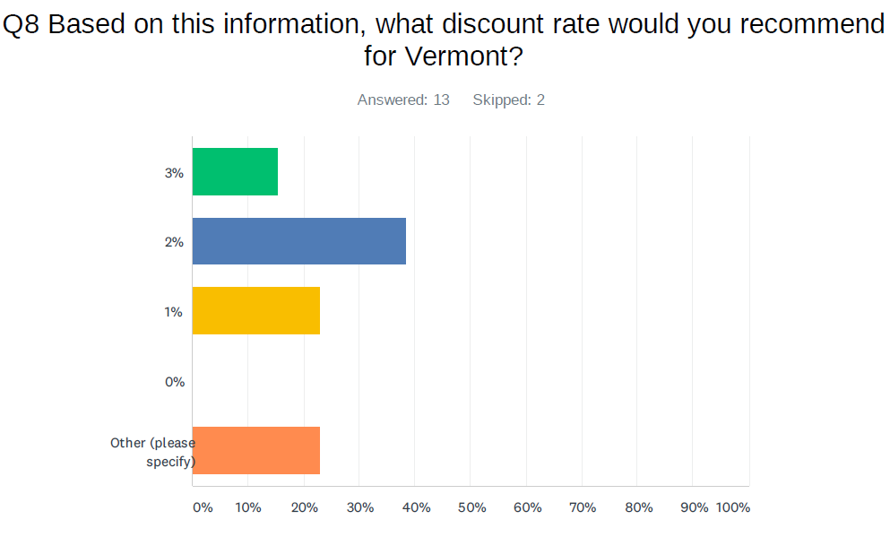
2
5
3
3
While this is a very small sample size, it is important to consider that the most popular choice among people who responded was a 2% discount rate for Vermont. This is in line with other social cost of carbon guidelines, including the New York State Social Cost of Carbon Guidance Document, as well as the federal guidelines on social cost of carbon released in February of this year. It is also important to note that the choice of a 2% discount rate is lower than the 3% discount rate currently used in the PSD cost of carbon model for Vermont.
The choice of a 2% discount rate is consistent with the results of the qualitative questions. For example, participants were asked to rate how strongly they agree or disagree with perspectives on several possible frames or lenses that decisions makers in Vermont could use to consider future costs and benefits for climate policies and strategies with long time horizons. The most popular position of the 3 positions offered (with 13 out of 15 respondents answering Agree or Strongly Agree), was the moderate position that, “It is important to account for impacts on future generations and doing so requires striking a balance between short-term economic growth and long-term impacts.” See the full survey and results in Appendix B for all 3 positions offered and the response for each.
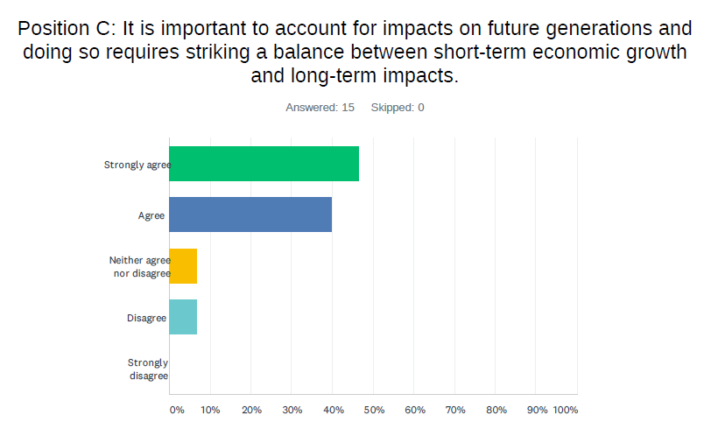
7
6
1
1
The choice of discount rate by the participants of the survey points toward the use of a 2% as the base social cost of carbon discount rate for Vermont.
The Cadmus/EFG team will now incorporate feedback and learnings from the polling exercise with the DSSC to improve the survey. For example, it was clear that there should be more of an explanation of the concept of a discount rate in the background information. We are planning to repeat the polling, with revisions based on feedback from the DSSC with all members of the VCC. We also plan to provide this report, as background to inform the VCC’s participation in the poll. The results from the responses from the VCC as well as from the DSCC will be used to inform our final recommendations for the SCC and discount rates to be used in the CAP and economic analyses.

SCC and Discount Rate Recommendations
- The results of the polling exercise, though limited in sample size, suggest a 2% discount rate based on qualitative and quantitative responses. This is consistent with recent guidelines from New York the Regional Avoided Energy Component Supply Study, and anticipated IWG Federal Guidelines. We recommend this as a base level for the VCC to consider and use for the CAP.
- We also recommend global damage based values based on IAM modeling, and suggest the SCC values from the Resources for the Future models in support of the New York State Guidelines for adoption by the VCC.

Appendices

Cost of Carbon Model

Access, Inputs, Assumptions and Formulae
Individual access to the tool may be achieved by emailing a request for a copy to: Philip.picotte@vermont.gov.
Detailed comments to the inputs, assumptions and formulae that appear to require revision (or that at least suggest a more detailed review than we are able to provide) include:
- Use electric avoided costs rather than retail rates to characterize added electricity costs of electric vehicles. The tool currently analyzes the cost-effectiveness of EVs using retail rates for gasoline and for electricity. From both a societal and program perspective, electric avoided costs should be used instead. Retail electricity prices were probably used because of a desire to capture the full range of differences in costs of operating internal combustion engine (ICE) car and an electric vehicle, including both fuel costs and maintenance cost differences, and the reference used for estimating such differences – AAA – bundled fuel and maintenance costs together. However, those two components can and should be separated – and it appears as though the AAA reference provides both components separately.
- Use more granular electric avoided costs and electrification measure load shapes. The tool currently uses estimates of annual average avoided costs of electric energy and capacity which may overstate the cost for some measures and understate the cost for others (because of seasonal and time of day differences in costs and when measures typically run). One alternative option to consider is use of a more sophisticated tool that uses annual load shapes for different electrification measures and applies them to avoided costs that are differentiated by season and time of day. The Efficiency Vermont (EVT) screening tool is one such option. If necessary, the avoided costs in the EVT tool could be modified to reflect a different reference case than are assumed for screening energy efficiency measures. It may make sense to at least test how different the estimated increase in electricity costs would be if the EVT tool was used. If the differences are not large, that would validate the use of simpler assumptions in the Department’s tool. As work continues throughout the Vermont Climate Council process, this will be reviewed further, including the approach being undertaken with the LEAP and Energy Action Network models.
- Reconsider the current 3% real discount rate. The current tool uses a 3% real discount rate to compute levelized costs. Societal discount rates typically range between 0% and 3%, so the current assumption is at the high end of that range. Long-term real Treasury Bond yields, which several states use as a reference for discount rates to apply when assessing cost-effectiveness of efficiency programs, imply a real discount rate on the order of 0.5% or less. For inter-generational concerns like climate change, a lower rate than 3% would seem more appropriate. Note that the issue of the appropriate discount rate for the social cost of carbon s addressed in elsewhere in this report. The outcome of that work with the DSSC and the full Climate Council should inform revisions to the social discount rate assumption in the Department’s tool.
- Ensure alignment between discount rate and the way electric avoided costs are expressed. It is unclear whether the electric avoided costs in the Department’s tool are expressed in real 2020 dollars (i.e., excluding inflation impacts) or in nominal dollars (i.e., with inflation impacts added), as there are references in that tab of the Excel file to both “2020 $” and to “nominal dollars”. The 3% real discount rate (or whatever revised real discount rate may be adopted) is appropriate for discounting values expressed in real terms. If there are any future dollar values expressed in nominal terms, they should either be revised with inflationary effects removed or a nominal discount rate would need to be applied to calculating their net present values.
- Consider disaggregating building electrification (heat pumps) by fossil fuel. Currently the tool analyzes heat pump retrofits for the average Vermont fossil fuel heated home. However, heat pumps will be much cheaper per ton of emission reduction in propane and oil heated homes than in gas than in gas heated homes. Disaggregating the analysis by fuel may be helpful. While that could theoretically raise some potential program or policy design issues, it may also suggest ways to craft policy and programs to prioritize solutions.
- Consider inclusion of cooling impacts for heat pumps. The TRM formula upon which estimates of heat pump kWh increases are based references cooling, but the calculation of fossil savings appears to be based entirely on heating coefficient of performance (COP), suggesting cooling impacts may not captured. It may be worth assessing the implications of including cooling impacts. Generally speaking, cold climate heat pumps are much more efficient at cooling than either central A/Cs or window A/Cs that they may displace. It is also important to note that anecdotal evidence suggests many customers are buying heat pumps in part because of interest in adding cooling capability; for such customers the baseline from which to assess impacts is some form of less efficient added cooling. Thus, in many cases, heat pumps will reduce cooling loads and related impacts on summer peak demand. On the other hand, for at least some customers, broad-based promotion of heat pumps will also likely result in increases in summer kWh and peak kW consumption relative to what would happen without such promotions. It is probably worth assessing the potential implications of the net effects of these impacts.
- Endeavor to disaggregate weatherization impacts for the state’s income qualified weatherization services by fuel – natural gas, fuel oil and propane. The model currently assumes that all weatherization savings are fuel oil savings. That assumption was presumably made because fuel oil is the most common heating fuel in the state and Office of Economic Opportunity (OEO) savings were reported only in CO2 rather than MMBTUs by fuel. While fuel oil may be the most common fuel, it is not the only one. OEO also saves propane, gas and electricity, all of which have lower emission rates than oil. Thus, GHG savings are likely modestly overstated. There is likely a way to get OEO savings by fuel type in MMBtus to get a more refined estimate.
- Refine estimates of EV incremental costs. The current tool assumes that the incremental cost of an EV is the difference between the national average cost of a mid-size sedan with an internal combustion engine (ICE) and the average manufacturer suggested retail price (MSRP) for EVs available in Vermont. That may be a bit of an “apples-to-oranges” comparison for a couple of reasons. First, the average EV available in Vermont is not necessarily representative of the average EV purchased. Second, the average mid-size sedan sold nationally may not be representative of the ICE alternatives to EVs purchased in Vermont. To use an extreme example to make a point, the cost of a Tesla is not comparable to the cost of a Ford or Toyota mid-size sedan. Ideally, estimates of the incremental cost of EVs should be based on comparisons of ICE and EV vehicles that are as similar as possible in the features that they each have – e.g. comparing a Ford Fusion ICE sedan with a Ford Fusion EV (but with other examples also included and approximate weighted averages computed). In short, averages can and should be used, but those averages should be for a reasonable assessment of comparable ICE and EV vehicles. This is analogous to how the incremental cost of efficiency measures is estimated by Efficiency Vermont.
- Review the assumed difference in electricity consumption and fossil fuel displacement between all-electric vehicle (AEV) and partial hybrid electric vehicles (PHEVs). Currently the tool assumes that PHEVs have ½ the MWh consumption as AEVs. No basis is provided for this assumption.
- Clarify assumptions about EV measure life. On the assumptions tab of the tool the measure life for EVs is stated as 12 years. However, in the EV tab the emission reductions and costs are assumed to be 15 years for PHEVs vs. only 12 years for AEVs. It is not clear why that distinction is made.
- Review/Correct anomalous assumptions in the EV tab. Why are EV CO2 impacts multiplied by 5/12 (AEV) or 5/15 (PHEV)? In cells C31 and D49 of the EV tab there are calculations of tons of CO2 reduction that multiply pounds of reduction by either 5/12 (for AEVs) or 5/15 (for PHEVs). It is not clear why. The same cells also incorrectly divide by 2,200 (the conversion to metric tons) whereas all other calculations in the tool divide by 2,000 to present information in short tons. Note that these two calculations do not appear to be used or referenced anywhere – and that the Summary Findings tab shows the correct calculation of cost per short ton reduced – so this is not a big issue. However, to avoid confusion those calculations should either be deleted or corrected.
- Tie electric capacity benefits of Tier II Resources to their capacity and coincidence factor. The tool currently bases estimates of capacity benefits on estimated annual electricity output (MWh), which is assumed to be spread evenly across all hours of the year, and then multiplying by the coincidence factor, the price per peak kW and other adjustments. This mistakenly undervalues the capacity benefits by a factor of about 5. Instead – as the tool does with net metering resources – the peak demand benefit should be computed by multiplying the nameplate capacity by the coincidence factor and then by price and other factors.
- Revisit heat pump water heater impacts assumptions. First, the assumptions in the tool are from an older (2016) TRM. Second, the tool appears to assume the least efficient HPWH is installed. Third, the current TRM has a heating penalty but no cooling or dehumidification benefit – these will be modest, but not zero. Finally, the current TRM appears to be based on average metered kWh from CVPS controlled electric water heaters which appear to have consumption levels on the order of 3000 kWh/year – which seems low from other data we have seen (controlled electric water heaters may be a biased sample).
Flow chart for harmonizing with SEI modeling and CAP

Social Cost of Carbon Survey and Results
This Appendix presents the survey questions and results from the DSSC Poll conducted as part of that Committees’ July 21, 2021, remote meeting. There were approximately 25 total remote meeting participants, and 15 people completed the survey as part of the guided exercise conducted by the Cadmus/EFG team.
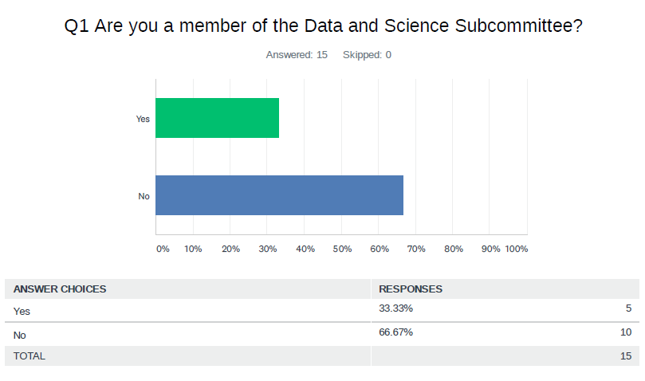

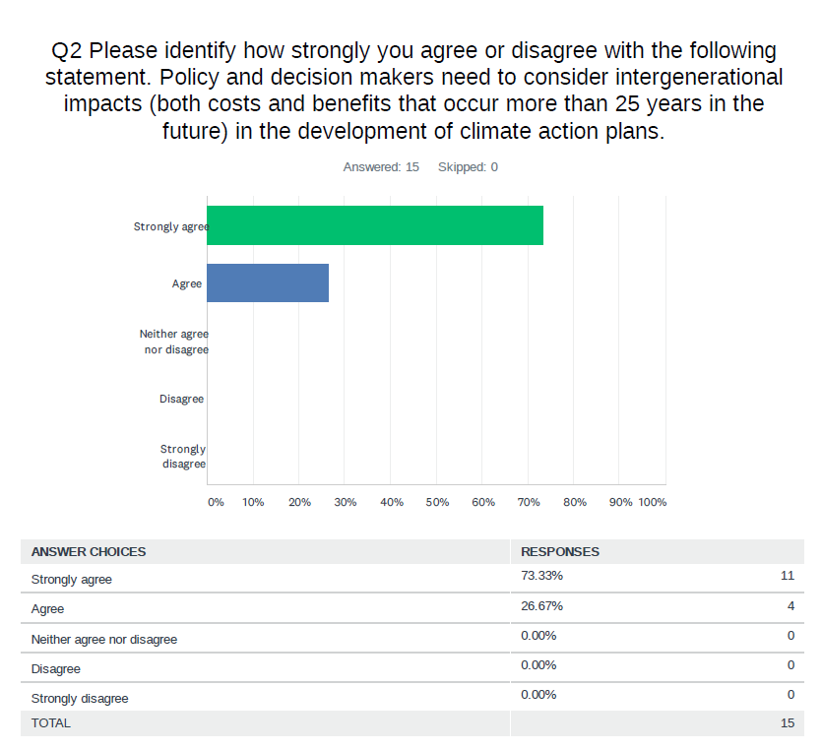

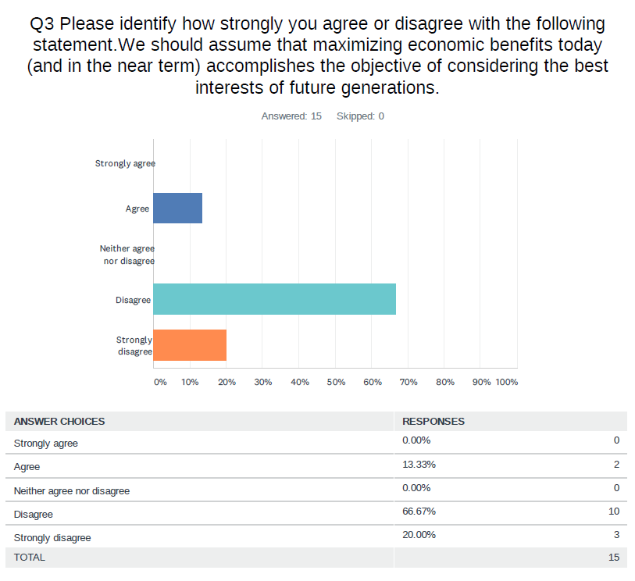

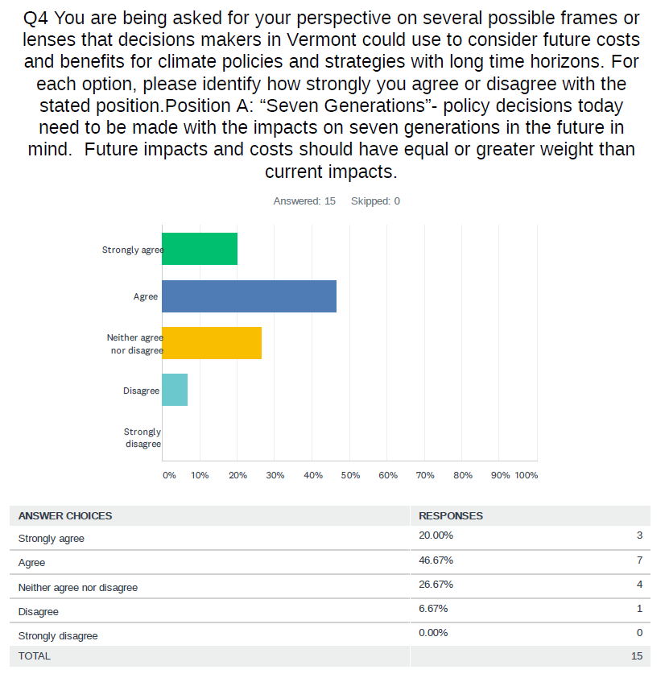

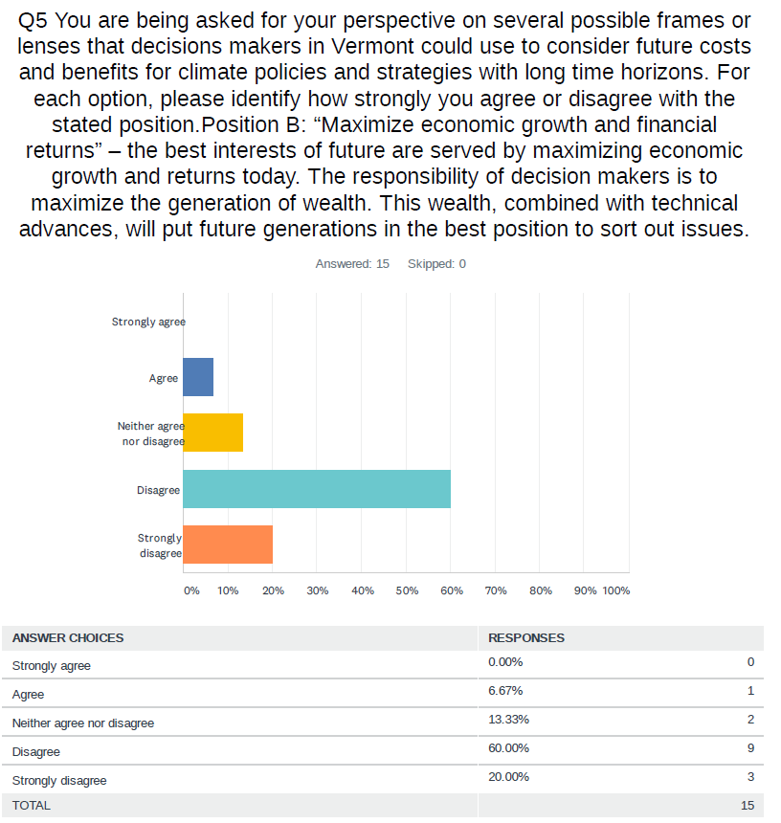

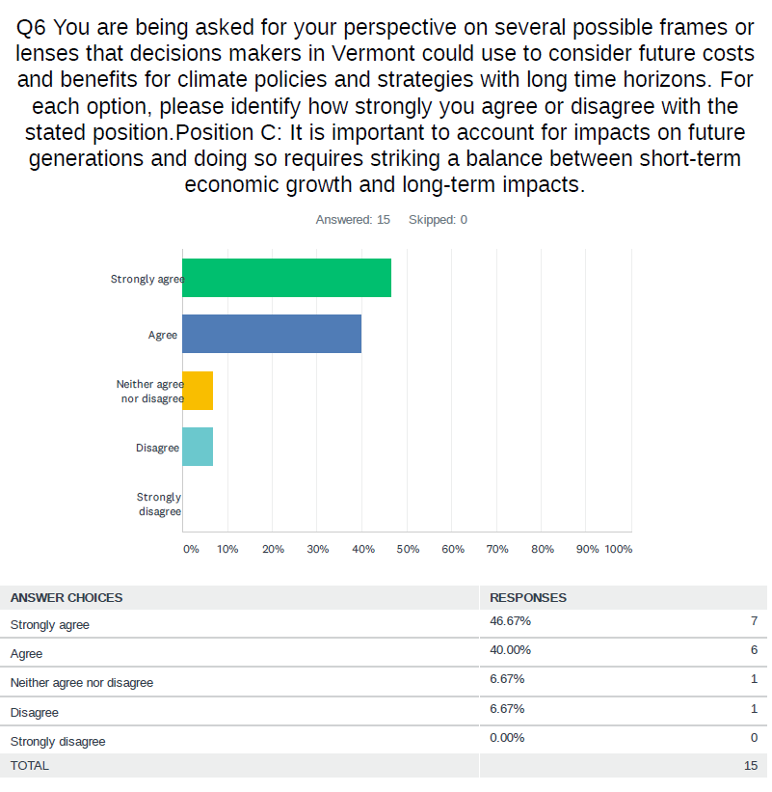

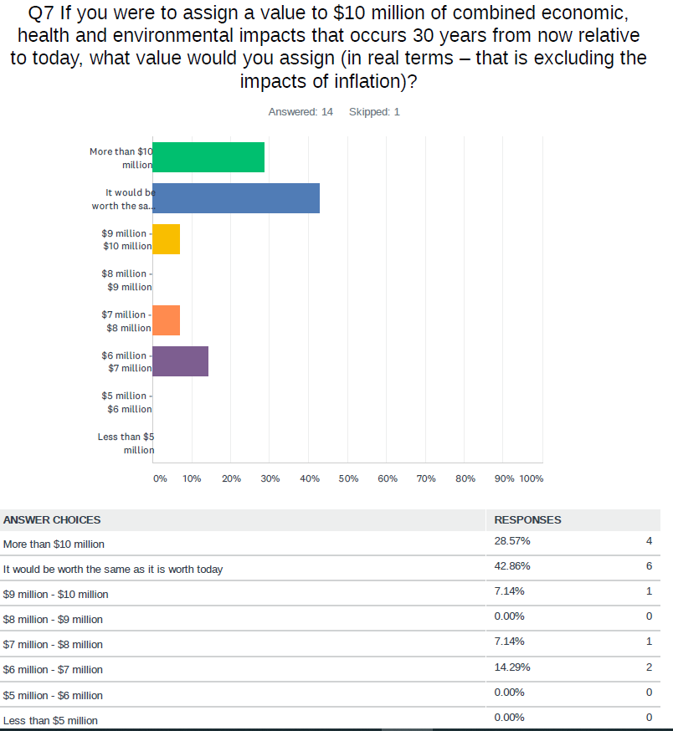

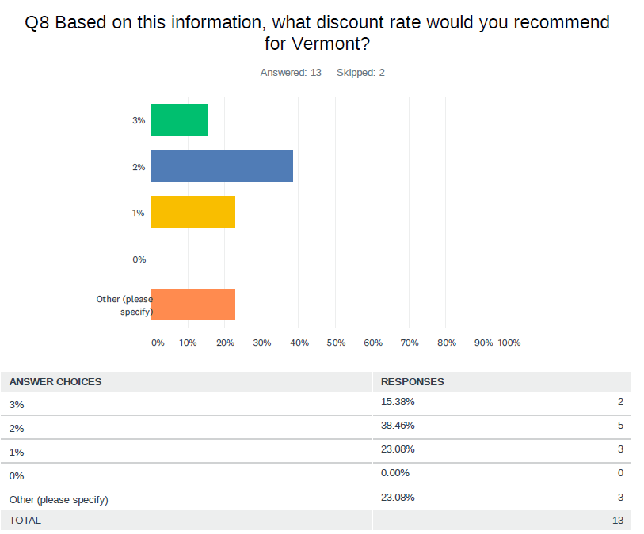
Question 8 is based on the table titled “U.S Social Cost of Carbon Dioxide by Discount Rate, Adjusted for New York State (2020$ per metric ton of CO2)”, which can be found below. The words “Recommended Range of Discount Rates” and “(Central Rate)” were removed from the survey question to allow participants to view the numbers without the NY DEC’s recommendation.
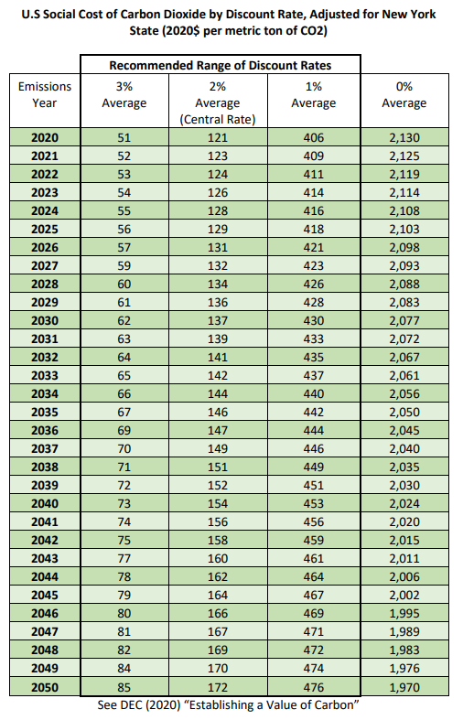
Source: Appendix: Value of Carbon, New York Department of Environmental Conservation, revised June 2021. https://www.dec.ny.gov/docs/administration_pdf/vocapprev.pdf.

https://neep.org/sites/default/files/media-files/se_report_neep.pdf
https://www.mass.gov/doc/ma-2050-decarbonization-roadmap/download
The tool is available for individual use by sending a request to Philip.Picotte@vermont.gov
A broader societal perspective would include costs and benefits outside of Vermont, particularly in other neighboring states and provinces.
Note that the “societal” perspective that the PSD is using in this model is more of an abatement cost and not the same as the “Social Cost of Carbon”. Discussion regarding the “Social Cost of Carbon” is provided later in this report.
It is important to understand that different analyses and perspectives do not identify and name various costs and payments in a uniform fashion. For example, the LEAP tool and a “Total Resource Cost” perspective would count the $235,000 as the incremental cost and would consider the incentive cost a “transfer payment”. Moving forward, the Cadmus/EFG team will ensure that the various perspectives are clearly articulated to the VCC throughout the CAP process.
Though the residential heat pump measures can be applied to some commercial buildings, particularly smaller buildings, their savings characteristics and costs are currently based on residential applications.
Nexus Market Resource (NMR) residential baseline study for Vermont.
https://www.healthvermont.gov/sites/default/files/documents/pdf/ENV_CH_WxHealthReport.pdf
https://www.iea.org/reports/multiple-benefits-of-energy-efficiency/health-and-wellbeing
https://rmi.org/increasing-home-value-home-energy-upgrades/
National Academy of Sciences, Valuing Climate Damages: Updating Estimation of the Social Cost of Carbon Dioxide (2017), https://doi.org/10.17226/24651.
Technical Support Document: Social Cost of Carbon, Methane, and Nitrous Oxide, Interim Estimates under Executive Order 13990. Interagency Working Group on Social Cost of Greenhouse Gases, United States Government, February 2021.
Establishing a Value of Carbon: Guidelines for Use by State Agencies, New York Department of Environmental Conservation, June 2021.
Resources for the Future provides extensive general background on social cost of carbon and technical issue briefs and working papers on their website available here.
Avoided Energy Supply Components in New England: 2021 Report, May 2021. Synapse Energy Economics. Section 8 Non-Embedded Environmental Costs.
See AESC 2021 Table 76 and Section 8 for further details.
Appendix: Value of Carbon. New York Department of Environmental Conservation, revised June 2021. https://www.dec.ny.gov/docs/administration_pdf/vocapprev.pdf.
Appendix: Value of Carbon. New York Department of Environmental Conservation, revised June 2021. https://www.dec.ny.gov/docs/administration_pdf/vocapprev.pdf.
Technical Support Document: Social Cost of Carbon, Methane, and Nitrous Oxide Interim Estimates under Executive Order 13990, Interagency Working Group on Social Cost of Greenhouse Gases, United States Government, February 2021, https://www.whitehouse.gov/wp-content/uploads/2021/02/TechnicalSupportDocument_SocialCostofCarbonMethaneNitrousOxide.pdf.
See Appendix G of Woolf, Tim et al., National Standard Practice Manual for Benefit-Cost Analysis of Distributed Energy Resources, published by the National Efficiency Screening Project, August 2020.
2021 Illinois Technical Reference Manual for Energy Efficiency, Version 9.0, Volume 1: Overview and User Guide, p. 59 (https://ilsag.s3.amazonaws.com/IL-TRM_Effective_010121_v9.0_Vol_1_Overview_09252020_Final.pdf).
“The coefficient of performance or COP (sometimes CP or CoP) of a heat pump, refrigerator or air conditioning system is a ratio of useful heating or cooling provided to work (energy) required.[1][2] Higher COPs equate to higher efficiency, lower energy (power) consumption and thus lower operating costs. The COP usually exceeds 1, especially in heat pumps, because, instead of just converting work to heat (which, if 100% efficient, would be a COP of 1), it pumps additional heat from a heat source to where the heat is required. Most air conditioners have COP of 2.3 to 3.5. Less work is required to move heat than for conversion into heat, and because of this, heat pumps, air conditioners and refrigeration systems can have a coefficient of performance greater than one. However, this does not mean that they are more than 100% efficient, in other words, no heat engine can have a thermal efficiency of 100% or greater.” Sourced from: https://en.wikipedia.org/wiki/Coefficient_of_performance

