Policy/Proposal Title:

Policy/Proposal Summary:

Climate Council Guiding Principles
These principles set expectations regarding:
- How Vermont’s Climate Council and its sub committees will conduct their work;
- What Recommendations3 are made by the Council; and
- How investments, implementation and oversight of climate action plans occur.

Say something about using the assessment questions and then using this tool… and don’t forget to read the principles

1 (low): Description of what might be low?

2 (moderate):

3 (high):

In reviewing the proposal, please consider the following prompts and their resonance to the goals and vision of this project.

Frontline/Impacted Communities  Score 1 – 3 on impression of meeting criteria | Please select 1 low to high 3
Frontline/Most Impacted Communities well defined in proposal | 1 | 2 | 3
Comments:

Proposal reflects understanding of existing inequities around the issue for  frontline/most impacted communities | 1 | 2 | 3
Comments:

Total
Analyzing Burdens and Benefits  Score 1 – 3 on impression of meeting criteria | Please select 1 low to high 3
Proposal clearly identifies how benefits are shared for frontline/most impacted  communities | 1 | 2 | 3
Comments:

Proposal clearly identifies who/what carries the burdens from the  recommendation, if any | 1 | 2 | 3
Comments:

Proposal includes solutions to shield frontline/most impacted communities  from experiencing burdens from the recommendation, if applicable | 1 | 2 | 3
Comments:

Proposal outlines the long-term/intergenerational impacts (positive or  negative) of recommendations on impacted communities | 1 | 2 | 3
Comments:

Total
Ensuring Equitable & Just Engagement  Score 1 – 3 on impression of meeting criteria | Please select 1 low to high 3
Proposal reflects inclusion of frontline/impacted communities in design and  implementation of recommendation | 1 | 2 | 3
Comments:

Vermonters can hear their voices in the recommendation | 1 | 2 | 3
Comments:

Recommendation written in plain language and easy to understand | 1 | 2 | 3
Comments:

Total
Funding & Data  Score 1 – 3 on impression of meeting criteria | Please select 1 low to high 3
Funding mechanism for recommendation is clearly defined | 1 | 2 | 3
Comments:

Funding mechanism makes recommendation affordable and accessible to  frontline/most impacted communities, if applicable | 1 | 2 | 3
Comments:

Proposal identifies data and indicators to determine success | 1 | 2 | 3
Comments:

Proposal includes process for consultation with frontline/most impacted  communities in assessment activities | 1 | 2 | 3
Comments:

Proposal includes plan for collection and review of data with frontline/most  impacted communities | 1 | 2 | 3
Comments:

Total

Implementation & Outcomes  Score 1 – 3 on impression of meeting criteria | Please select 1 low to high 3
Proposal identifies new jobs/business/employment opportunities for the  recommendation | 1 | 2 | 3
Comments:

Jobs created by recommendation offer fair, high paying positions with good  benefits | 1 | 2 | 3
Comments:

A wide range of traditionally underserved Vermonters and unions are  prioritized in the jobs created by the recommendation | 1 | 2 | 3
Comments:

The recommendation increases community trust, cooperation, respect, and  mutual support | 1 | 2 | 3
Comments:

The recommendation provides a specific, quantifiable commitment to a just  transition | 1 | 2 | 3
Comments:

The recommendation supports the natural environment and promotes fairness  to all living things | 1 | 2 | 3
Comments:

Total

Total scoring (20 low to 60 high):

Direct Benefits to Underrepresented/Most Impacted Communities (use blank spaces as needed to add)
The recommendation provides direct benefits for the following groups:
Agricultural Sector | Yes | No
Black/African-American, Brown, Latinx, Asian, Pacific Islander, and Indigenous  communities and Native nations | Yes | No
Disabled and chronically ill people | Yes | No
Displaced due to severe weather | Yes | No
Older Vermonters | Yes | No
Formerly incarcerated individuals | Yes | No
Immigrants, regardless of immigration status | Yes | No
LGBTQIAP+ individuals | Yes | No
People living with low or very low incomes | Yes | No
Outdoor laborers | Yes | No
Recent graduates of the foster care system | Yes | No
Unions/Organized Labor | Yes | No
Women | Yes | No
Young People | Yes | No
 | Yes | No
 | Yes | No
 | Yes | No
 | Yes | No
 | Yes | No
 | Yes | No
 | Yes | No

Narrative on Impacted Communities:

Recommend: Y - N

Explanation:

The following questions were developed by the Just Transitions Subcommittee to help each Subcommittee put the Guiding Principles into practice. They aim to better identify, understand, and address the social impacts, types of vulnerable populations, and engagement process of individual policy recommendations. These are not comprehensive, but rather indicative of the analysis required to ensure a Just Transition for Vermont. It is recommended you develop narrative responses for each of the questions listed for inclusion in your proposals for consideration.
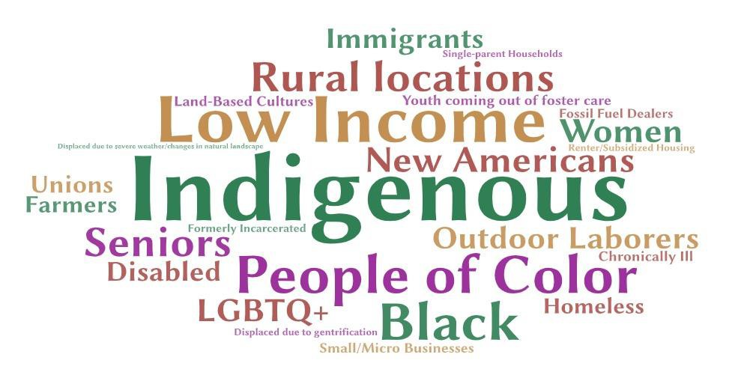

IMPACTED & FRONTLINE COMMUNITIES

- Which frontline and impacted communities might be most impacted by this recommendation?
- How do these communities experience inequity today around this issue?

ANALYZING BURDENS & BENEFITS

- Does this recommendation maintain existing inequities, make them worse or improve the status quo?
- Who will benefit from this recommendation and how does this recommendation help benefits be shared or targeted to help frontline and impacted communities the most? Be specific about the communities and the ways these communities will benefit.
- Which communities will be burdened the most by this recommendation and how can that burden be shifted away from impacted communities?
- What are the long-term and potential intergenerational impacts of this recommendation for identified communities?

ENSURING EQUITABLE & JUST ENGAGEMENT

- How have frontline and impacted communities been part of creating and implementing this recommendation? And how will they in the future?

- In what ways was this recommendation shaped by engagement with Vermonters, especially by impacted and frontline communities?
- In what ways does this recommendation recognize different types of knowledge in its design and proposed implementation?
- In what ways can Vermonters hear their voices in the plan?
- Does the recommendation use plain language that is easy for all Vermonters to understand?

FUNDING & DATA

- How will this recommendation be funded? What percent of funding will be specifically to support frontline, low-income and impacted communities? Is there enough funding to make it affordable and accessible for identified communities? People with living with lower incomes or in rural areas?
- How will we know about the impacts of this recommendation on identified communities? Which data or indicators will be needed? What process was used to determine the indicators are resonate and relevant to most impacted community needs? How will it be collected and shared?

IMPLEMENTATION & OUTCOMES

- What kind of jobs are will be created by this recommendation? Will those jobs be fair, high-paying jobs with good benefits? How will traditionally underserved Vermonters and unions be prioritized for these jobs?
- How does will the recommendation strengthen community trust, cooperation, respect and mutual support?
- How does this recommendation express make a specific commitment to a just transition now and for future generations? The commitment must/should be quantifiable and identify who is accountable.
- How well does the recommendation support the natural environment? How well does it promote fairness to all living things?

Developed by Kiah Morris/Kiah Morris LLC for the State of Vermont 2021 for the Vermont Climate Council. Distributed with full permissions. No compensation has been provided for the creation of this tool.

